Charlie Nitschelm  
Trevor Blampied  
4/20/20  
Geography of China  
Professor Lan

Term Project Step #4 – Hong Kong Research Article

# Introduction

Throughout the semester, Hong Kong, and the impact that its geography has had on its history and current issues, was studied. During each step, more specific aspects of Hong Kong were researched. These aspects ranged from the physical environment, to the political climate of the region. The economy and culture of Hong Kong was also researched. Lastly, Hong Kong and some of its issues were compared and contrasted to similar issues within the United States.

# Background

Hong Kong has a rich history dating back to January 25th, 1841 when the British began to occupy the island. The British were using the island as a military base during the First Opium war which lasted from 1839 to 1842. Hong Kong island was the perfect strategic base due to Britain's superior navy and its location in the Pearl River Delta. In addition to Hong Kong being leased to Britain, the new Territories and other islands were leased to Britain. The lease expired in 1997 and Hong Kong was returned to Chinese control.

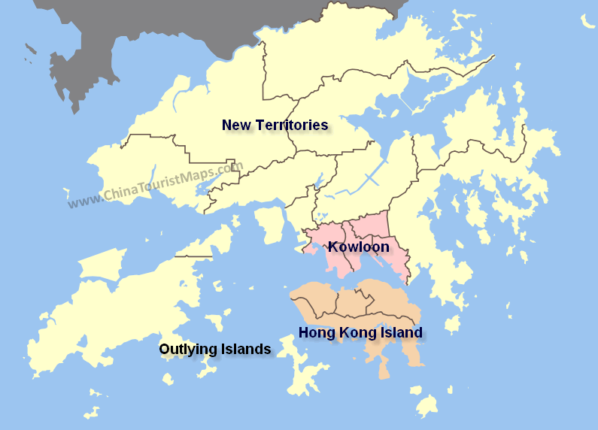

Figure - Map of Hong Kong Island, Kowloon, New Territories, and Islands

“The handover was meant to establish a “one country, two systems” relationship between China and Hong Hong that would last until 2047, with Hong Kong existing as a special administrative region.” (How Hong Kong Came Under 'One Country, Two Systems' Rule.) After the First Opium war, fought between the Qing Dynasty and Britain, Britain created a treaty that allowed them to occupy Hong Kong and the surrounding area. This forced open trade with China to supply Europe with luxury goods such as silk and tea. The Second Opium war , fought between Britain and France vs the Quin Dynasty from 1856 to 1860 cemented the importation of opium into China. During negotiations, Kowloon ceded to Hong Kong and the New Territories were leased for 99 years as well.

Hong Kong was not always ruled by the British. During World War Two, Japan successfully invaded and occupied Hong Kong. Britain and China were able to liberate Hong Kong at the end of the war. In 1982, Chinese and British leaders started the steps to negotiate the transition of Hong Kong back to Chinese Rule. The lease however did not apply to Hong Kong and Howloon but rather to the New Territories but, “Prime Minister Margaret Thatcher ultimately didn’t think that those two regions would be able to survive on their own…” (How Hong Kong Came Under 'One Country, Two Systems' Rule.) Hong Kong was not included in the discussions on the end of the lease and their own return to China. “What choice did they have?” Tsang asks. “If they said, ‘No negotiations,’ the Chinese would take over without a deal. If they declare independence, the PLA would invade. So neither of those are actually options-independence was not an option, refusing or rejecting integration was not an option” (How Hong Kong Came Under 'One Country, Two Systems' Rule.) Two years later, the Sino-British Joint Declaration was signed. This declaration detailed that Britain would relinquish control of Hong Kong to China in 1997 but Hong Kong would keep its “Current social and economic systems” (Sino-British Joint Declaration)

# Comparison

Currently, Hong Kong has a huge political fight going on with the rights Beijing has over the people of Hong Kong. “Hong Kong has Special Administrative Region status which provides constitutional guarantees for implementing the policy of “one country, two systems” (Politics of Hong Kong).” This means that Hong Kong isn’t politically controlled by China, so they have a separation between China’s communist government and the more free-economy and free-speech Hong Kong has adopted since its British rule. “The idea of one country, two systems was proclaimed in which Hong Kong was to govern itself for fifty years, during which it was allowed to issue its own currency, provide its on police and administrative apparatus, continue its separate and independent judiciary, and operate a free and market-based economy (Veeck 373).” Since Hong Kong was transferred to China control in 1997 and the adoption of the ‘one country, two systems’ was agreed upon, Hong Kong has been able to maintain its way of life, and continues to grow stronger as it doesn’t align with the communist way. They still have more than 25 years of this deal being active (Veeck 364). A series of riots have broken out over the past couple of years fighting the invasion of mainland China on Hong Kong’s way of life that have created over the last few decades. These fights wish for a “Complete withdrawal of the extradition bill from the legislative process (Politics of Hong Kong).” The five demands of the protest are

1. Full withdrawal of the extradition bill from the legislative process
2. Retraction of the characterisation of the 12 June 2019 protests as “riots”
3. Release and exoneration of arrested protesters
4. Establishment of an independent commission of inquiry into police behavior
5. Universal Suffrage for Legislative Council and Chief Executive elections

One particular issue that has arisen from this push is the standard of how Hong Kong chooses its leader, the executive director. Currently, mainland China has put forth a few candidates they approve of that the main delegates of Hong Kong can vote from. This restricts the freedom Hong Kong wants to pick its leader independently from the approval of mainland China. “More demonstrations followed in which local democratic parties demanded a greater voice in selecting candidates for office and a broader suffrage that would enable local people to vote for candidates of their choice (Veeck 375).” Although each political issue that happens around the world is unique, there have been similar events and fights that have occurred within the United States that could be studied to offer more insight to the current climate in Hong Kong now. These include the US Civil War and the current US Gun Rights laws.

During the era of the US civil war (1860’s), there were two competing goals between the North and the South. The South’s goal was “to secure independence from the North and to establish an independent nation free from Northern political oppression and the repression of slavery (Civil War).”

The North varied slightly throughout the fight but essentials “its initial goal was to reconcile the Union, while its mid-war goal became to reunite states under a Union in which slavery was not tolerated.  The war from beginning to end would be a noble crusade for democracy for all people, not just in America, but throughout the world (Civil War).” These competing priorities sparked the greatest death war the US has ever engaged in. It is often debated about the overall outlook of the North and how leadership was able to pull such a varied population to fight the South. “To Northerners, in contrast, the motivation was primarily to preserve the Union, not to abolish slavery (American Civil War).” Although it is sad now to think that the people of the North weren’t driven by the idea of abolishing slavery which is so universal within the United States now, the people still stood by the overall mission of the North, which included the removal of the South mindset that so heavily relied on slave labor.

The end of the 99 year lease of Hong Kong from China to the British can be compared to the Civil War between the North and the South of the United States. Though the origins of the situations differ, the end goal of Hong Kong and the South are similar. One of the goals of the South was to “secure independence from the North and to establish an independent nation free from Northern political oppression…”(gorhistory.com) Along the same vein, one of the Five Demands from the Hong Kong protests is Universal Suffrage for the Legislative Council, essentially allowing them to elect their own government and not be pupated by China.

For a majority of the population in the US during the Civil war, they maintained a neutral state, not wanting to fight their own people. But the drive of a pure democracy against the more slavery-based state of the South drove the people on both sides to fight, as both sides were rooted in what they were taught as they were raised, including the young fighters in the front lines. The same fundamental concept can be seen in Hong Kong, with many of the Hong Kongers taking this invasion of Beijing and mainland China as unacceptable, taking to the streets to vocalize what they believe in, a right mainland Chinese do not have. The situation is different because the area involved in this is so much smaller that the whole community it is impacting is close and well-knit. It drives more people to be aware of what is happening, enabling more communication and organization. China also acts much differently then many other countries in the world in how they deal with their people internally. As we continue to look to the future of how this situation can play out, it is important to note how the US Civil War ended, and how that affected the following years. “The decision to free the slaves on paper via the 13th Amendment did nothing to give them real access to political, economic, or social freedom - thus setting into motion 100 years of Jim Crow laws and racial violence across the nation (Civil War).” Even though a winner will likely arise soon, it is very hard to completely overcome a mindset, either for Hong Kong or China, that has been rooted for so many years in their people.

US Gun Laws have been a popular area of discussion and reform over the past several years in the US with the rise of public shootings throughout the country. Fundamentally, many people want more protections for themselves with their families by limiting the guns people can obtain and include deeper checks and wait periods to qualify for a firearm. The pro-gun people, mainly concentrated in the south, have taken to the streets as states begin to create new laws to restrict a fundamental right many believe should never change.

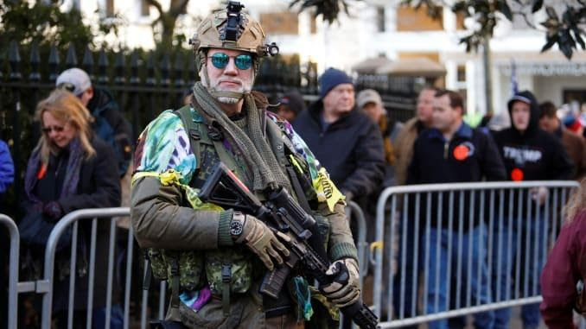

Figure - An armed militia overseeing gun right protests (Armed US Gun Rights)

“More than 22,000 armed gun-rights activists peacefully filled the streets around Virginia’s capitol building on Monday to protest gun-control legislation making its way through the newly Democratic-controlled state legislature (Armed US Gun Rights).” The people protesting know that if they fall over in certain areas of the states, it will continue to roll over every state and federal law. “‘What’s going on here, if not stopped, will spread to other states,’ said Teri Horne, who had traveled to Virginia from her home in Texas with her Smith & Wesson rifle and .40-caliber handgun (Armed US Gun Rights).”

Hong Kongers have organized and protested the invasion of Beijing and mainland China with the same mindset of the states trying to change the law for gun rights. It is a popular mindset that once a fight is not fought for, the frontline for Hong Kong will continue to kneel over for mainland China. In the past, many people have invaded others, but the question remains if what happens is sustainable and actionable. “‘Some of these bills being proposed are just unconstitutional and we will not enforce them,’ Vaughan said. ‘As a sheriff I am the last line of defense between law-abiding gun owners and the politicians who want to take away their rights.’ (Armed US Gun Rights).” Will China be able to ensure that Hong Kongers will respect China and continue to live life adopting the new laws of the land imparted from Beijing.

The situations are still vastly different for the actual outcome of the protesting loss. If US pro-gun activists lose, they suffer the ability to obtain new guns and own their current ones. If Hong Kong protesters lose, they suffer huge amounts of rights many of us take for granted living in the United States. Many Hong Kongers fundamentally do not identify as being a part of China, so the new reality that might await them is frightening. That is the fundamental reason protests have escalated to violent ones in Hong Kong for the overall severity that might hit them if they do not fight and win.

# Discussion

The conflict between the North and the South in the United States had a very similar goal to today's China vs Hong Kong struggle. The goal being to unify a country. However the ideas behind each movement are different in their nuances. The south wanted to be able to rule themselves and be free of northern political oppression, which is exactly what Hong Kong wants from china. The other goal was to be free of the represion of slavery. Hong Kong does not want to be free from China so it can have slaves. The origins of the situation are different as well which impacts which fight just and which is not. Hong Kong governed itself for many years and grew apart from China during this time. The act of the CCP injecting itself into Hong Kong by providing Hong Kong with candidates for the Chief Executive role is clearly a breach of democracy. The civil war’s impact in part freed people from oppression which is the exact opposite of what is happening with Hong Kong as the CCP is trying to slowly gain control over the government of Hong Kong. Over the course of history, being ruled by people you don’t elect, sows distrust and aversion towards the ruling people. The most obvious case of this Britain ruling the colonies in the 18th century.

The gun rights protests and the Hong Kong protests are on completely different scales, one in the sheer number of people protesting, and the other on a moral level. The Hong Kong protests are massive with nearly two million marchers in some cases which is over 25% of the population protesting what they believe is right.

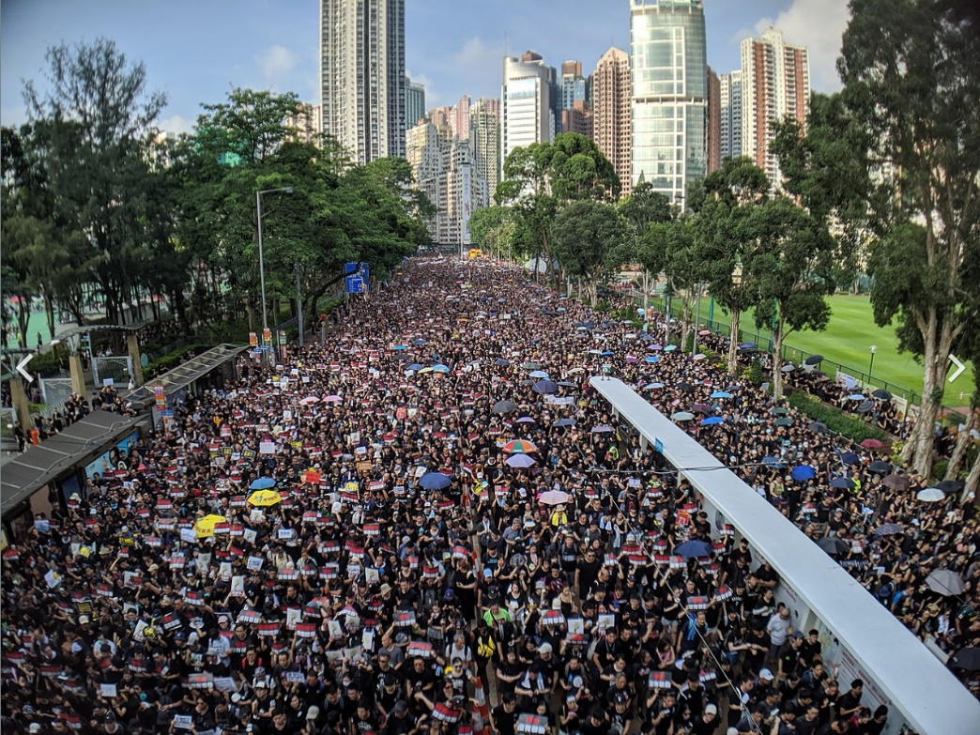

Figure - CHRF March on June 16th

The gun rights protest didn’t even reach a ten thousandth of a percent of the US population. The gun right protests are a radical group that are not supported in person by the nation. The gun rights protesters are protesting the rights to be able to keep a deadly hobby that is used often and continuously to murder fellow citizens, whether that be via school shootings or mass shootings. There is no moral ground to stand on to own guns with high magazine capacity or high rates of fire. If the gun rights activists lose and the US government buys back high capacity guns, their way of life does not change at all. On the contrary, if the Hong Kong protesters give up, their way of life will change drastically as the CCP will inject itself into more than just the government of the country. It will eventually take over the legal system and the economy will change as well. Whether or not the CCP is good or bad here is not the issue, its that Hong Kongers want to be able to govern themselves as they have been doing for the last 100 years quite successfully and losing the battle over the extradition bill would be the first step.

# Conclusion

Many of the situations that arise in current politics have been experienced before in other countries or civilizations in our past. It is our job as people to research and learn from what has happened to reflect our decisions now. Although China and the U.S. is vastly different in many ways of life, comparisons can be made that can help navigate people to understand and learn from another. It also helps understand that although we are rooted in differences, both people can experience similar events and situations that occur with any group of people.

# Works Cited

Veeck, Gregory. *China's Geography: Globalization and the Dynamics of Political, Economic, and Social Change*. Rowman & Littlefield, 2016.

1. “Environment of Hong Kong.” *Wikipedia*, Wikimedia Foundation, 19 Sept. 2019, en.wikipedia.org/wiki/Environment_of_Hong_Kong.
2. “Politics of Hong Kong.” *Wikipedia*, Wikimedia Foundation, 4 Jan. 2020, en.wikipedia.org/wiki/Politics_of_Hong_Kong.
3. “Economy of Hong Kong.” *Wikipedia*, Wikimedia Foundation, 9 Feb. 2020, en.wikipedia.org/wiki/Economy_of_Hong_Kong.
4. “Culture of Hong Kong.” *Wikipedia*, Wikimedia Foundation, 5 Jan. 2020, en.wikipedia.org/wiki/Culture_of_Hong_Kong.
5. “History of Hong Kong.” *Wikipedia*, Wikimedia Foundation, 18 Mar. 2020, en.wikipedia.org/wiki/History_of_Hong_Kong.
6. “History.” *History | Hong Kong Tourism Board*, [www.discoverhongkong.com/us/plan-your-trip/traveller-info/about-hong-kong/history.jsp](http://www.discoverhongkong.com/us/plan-your-trip/traveller-info/about-hong-kong/history.jsp).
7. “Hong Kong Human Rights and Democracy Act.” *Wikipedia*, Wikimedia Foundation, 26 Feb. 2020, en.wikipedia.org/wiki/Hong_Kong_Human_Rights_and_Democracy_Act.
8. “Hong Kong.” *Wikipedia*, Wikimedia Foundation, 26 Mar. 2020, en.wikipedia.org/wiki/Hong_Kong.
9. “The Joint Declaration.” *The Joint Declaration - 2*, [www.cmab.gov.hk/en/issues/jd2.htm](http://www.cmab.gov.hk/en/issues/jd2.htm).
10. Little, Becky. “How Hong Kong Came Under 'One Country, Two Systems' Rule.” *History.com*, A&E Television Networks, 3 Sept. 2019, [www.history.com/news/hong-kong-china-great-britain](http://www.history.com/news/hong-kong-china-great-britain).
11. “American Civil War.” *Wikipedia*, Wikimedia Foundation, 30 Mar. 2020, en.wikipedia.org/wiki/American_Civil_War.
12. *Civil War*, gorhistory.com/hist110/unit4/CivilWar.html.
13. “Armed US Gun Rights Activists Rally against Proposed Virginia Gun Laws.” *CNBC*, CNBC, 20 Jan. 2020, www.cnbc.com/2020/01/20/thousands-of-armed-activists-gather-at-virginias-pro-gun-rally.html.